Detailed Design Specification

POC PORTAL
Version 1.0.0

1 GENERAL 1
1.1 Project Overview 1
1.2 Design Overview 1
1.3 Conversion Impact (optional) 2
1.4 Customer Management Impact 2
1.5 Technical Architecture Impact 2
1.6 Security Impact 2
1.7 Application Flow Diagram 3
1.8 Assumptions 4
1.9 Impact Inventory and Descriptions 4
1.10 Access Control Matrix (optional) 7
2 DATA 7
2.1 Data Classification Template (optional) 7
2.2 Physical Data Model 8
2.3 Record Definitions (optional) 8
3 ONLINE 8
3.1 Page Descriptions & Page Layouts (3.2) 8
3.3 Page Edits 9
3.4 Business Logic / Calculation Rules 9
3.5 Search / Audit Record 11
4 BATCH 11
4.1 Program Description 11
4.2 Business Logic / Calculation Rules 11
4.3 File Layouts (Inbound & Outbound) 11
4.4 Run Controls & TWS Considerations 11
5 REPORTING 12
5.1 Report Description 12
5.2 Report Layout 12
5.3 Break Logic 12
5.4 Distribution & TWS Considerations 12
5.5 Sort Order 12
5.6 Business Logic / Calculation Rules 12
5.7 Execution/Initiation Instructions 13
5.8 Unit Test Conditions 13
APPROVAL 14

GENERAL

Project Overview
The POC PORTAL is a web application that acts a central location for POC agents to find and record information. The Portfolio Operations Center [POC] agents need to respond to Site-based incidents. The current information sources and response notes are in disparate systems. The POC Portal is a system which consolidates Real Estate information, ORR information or any additional Site information PLUS the ability to add Site Specific Notes. This system alleviates the need to login to multiple systems to access site information and notate any site-specific data. This saves time and helps streamline the agents’ need to respond quickly to any site event and relay plus capture any information that is critical in a site event that comes into the War Room.
The Portfolio Operations Center [POC] main focus is in managing risk, emergency events and communications to ensure the continuity of facility operations and delivery of safe and secure facilities. Although security is a top priority for the POC there are also other services that are provided.

Design Overview
This C# Web Application uses a tab-based presentation in order to present United Health Group site information and allow for site information to be submitted and reported on. The website consists of the following pages.
The Site Info Tab is the presentation and response component of the Web Application. Site Information is managed and maintained by Jones Lang Lasalle [JLL] by use of a proprietary Real Estate application known as FRED. The information in FRED is maintained by Site Managers****. Each site is designated by a MAILROUTE an alpha-numeric designation in the form of <XX000> i.e. MN008. A dropdown box is populated with Distinct MAILROUTE values that are sourced from the FRED data.
JLL creates an output of two files from FRED that are delivered to our servers into the location E:\inbound.
These two files consist of Site Information and Site Contact Information.
Home Page: Default landing page. Login Button only allows specific AD Global Groups to access the site
Logged in: Multiple Tabs and Subtabs of information.
TABS:
Site Info: Consists of Three Tabs: Main, FRED and POC Data
MAILROUTE dropdown contains all the UHG Mailroutes. Site Contact information Stays visible
SUBTABS
Main: Once MAILROUTE selected this page populates with the site contact information plus the ORR data Sharepoint. All data is presented collapsed and expandable on demand.
FRED: Every datapoint other than contact information is available
POC Data: This is an input tab. Specific Site data can be captured and responded to by agents and looked up by others in the POC
System Information: Consists of Three Tabs: Main, FRED and POC Data
SUBTABS
IP: Ping result of all Cameras, NVR and Panel are visualized.

Customer Management Impact
POC Agents are the users/consumers of the POC Portal. Consolidated Site Information presentation and Site Specific information capture and presentation helps Agents respond to Site Events and Alarms in a consolidated location.

Technical Architecture Impact
POC Portal uses the FRED application Site data [Jones Lang Lasalle] . POC PORTAL will utilize its own back-end SQL database.

Security Impact
A windows service account, ms\buildsec is the POC service account that is used for managing data access and writing. Active Directory Global Groups [poc_system, poc_agent, CS_Disarch] are used to validate login.
https://pocportal.uhg.com/IA4/login
Login automatic timeout is set at 30 minutes.

Application Flow Diagram

Assumptions
N/A

Impact Inventory and Descriptions
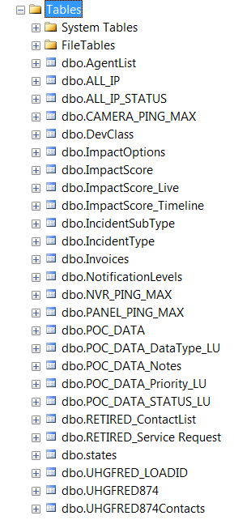 | 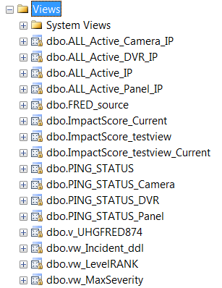 | 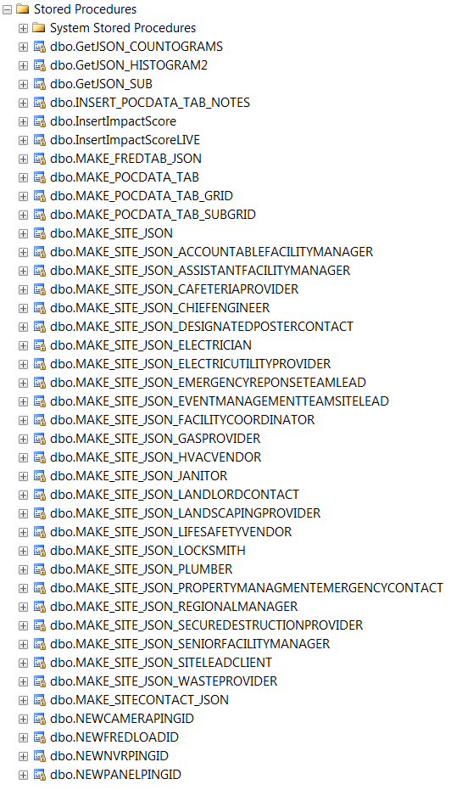

Access Control Matrix (optional)
N/A

DATA

Data Classification Template (optional)
N/A

Physical Data Model
N/A
*Note: A Physical Data Model diagram is not necessary for a record change or for multiple tables or files that are not related.

Record Definitions (optional)
N/A

ONLINE

Page Descriptions & Page Layouts (3.2)
- Home Page

- Landing Page – with Main subtab
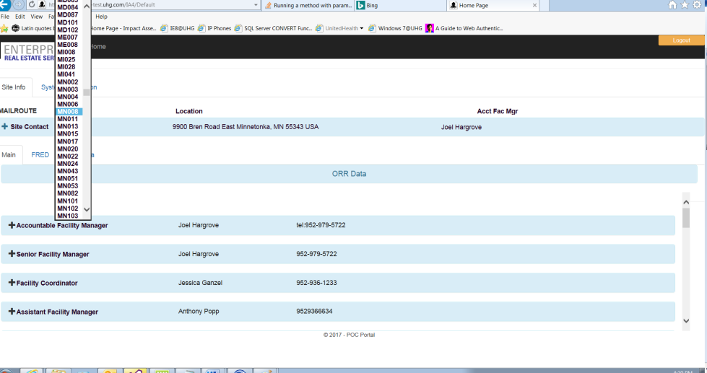

- FRED - subtab
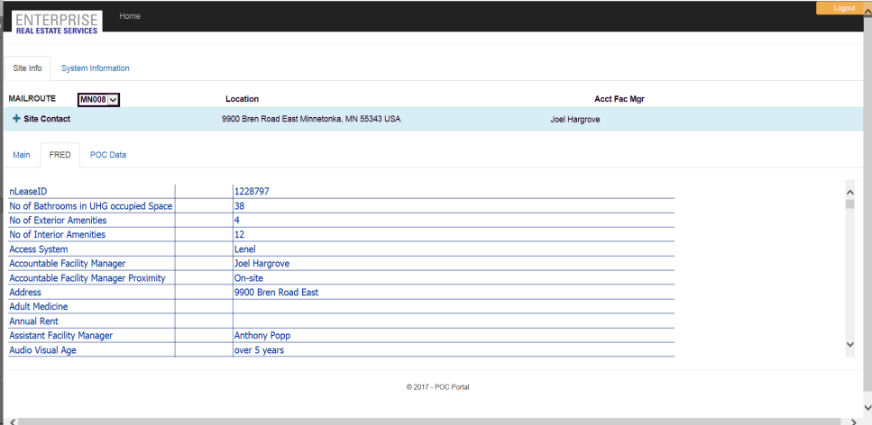
- POC Data - subtab
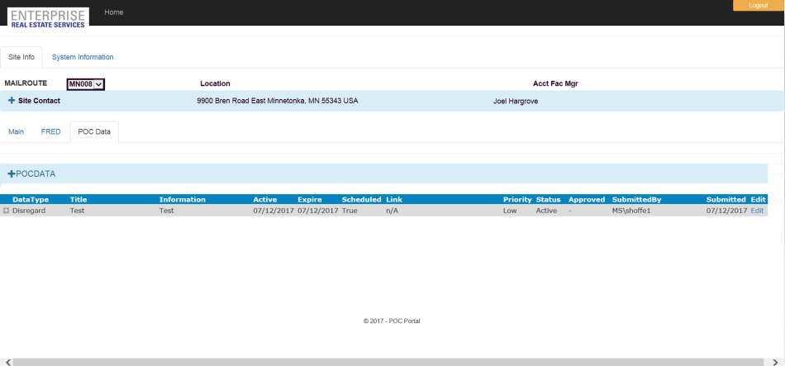
- System Info – IP:Ping Test
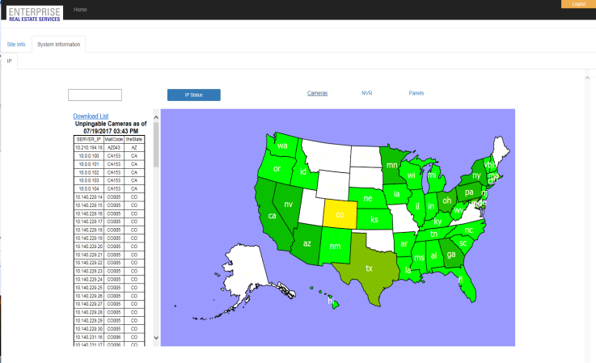

- LinkSite
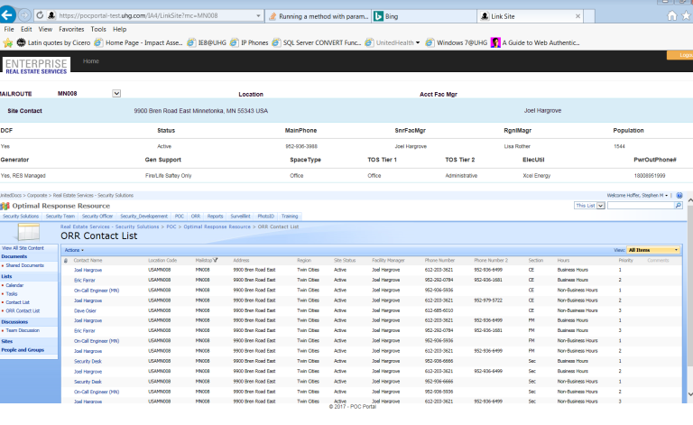

Page Edits
N/A

Business Logic / Calculation Rules
N/A

Search / Audit Record
N/A

BATCH

Program Description
UpdateFRED.ps1 a powershell script that deletes all data in POC PORTAL database tables UHGFRED874
And UHGFRED874Contacts then takes FRED [JLL sourced] excel data and bulk inserts it into the two tables.
UpdateFRED.ps1 is a powershell script that performs the following steps:
- Delete any FRED data from UHGFRED874 and UHGFRED874Contacts that is over 14 days old.
- Read latest Fred and Fred Contacts excel files.
- Bulk upload into the UHGFRED874 and UHGFRED874Contacts into the two tables.
- UHGFRED874 holds UHG Site Information
- UHGFRED874Contacts holds all Site Contact information.
- Errors are written to $Logfile = "E:\logs\FRED_Update_FAILURE_$TempDate.log"
- Try|catch|finally is used with Exit codes to notify TWS [$ErrorActionPreference = "Stop", [Environment]::Exit("31"); on error or [Environment]::Exit("9"); on successful

Business Logic / Calculation Rules
XLS files of Site locations are FTP-ed to E:\inbound folder. UpdateFRED.ps1 deletes files older than 14 days.

File Layouts (Inbound & Outbound)

Run Controls & TWS Considerations
  - Job Stream Name = RIA_RIA_UPDFRED
  - Job Name = RIA_RIA_WT_UPDATE_FRED_PS_PRD
  - Description = UpdateFRED.ps1 a powershell script that deletes all data in POC PORTAL database tables UHGFRED874 And UHGFRED874Contacts then takes FRED [JLL sourced] excel data and bulk inserts it into the two tables.
  - Schedule = Daily @ 04:30 CT
BATCH SCRIPTS AND SCHEDULING
Scripts
Import Script Name: UpdateFRED.ps1 Action: Delete and Replace
Description: N/A

TWS Calendars
Calendar Name: Action: N/A
Description: N/A

TWS Jobs
Job Name: N/A Action: N/A
Description: N/A

REPORTING

Report Description
None at this time

Report Layout
N/A

Break Logic
N/A

Distribution & TWS Considerations
N/A

Sort Order
N/A

Business Logic / Calculation Rules
N/A

Execution/Initiation Instructions
N/A

Unit Test Conditions
N/A

Modification History
Version # | Description | Author | Date
1.0.0 | Initial Version | Stephen Hoffer | 7/19/2017

APPROVAL
Documented evidence must be created, stored, and consistently available upon request.

This change is technology-related and no Business Owner approval is required.

This change is related to a business request.

Required Verbiage:

Project Name: POC PORTAL

I have received and reviewed the Design Document shown above. I acknowledge and agree with the design.

Business Owner Approval (if required):

Business Owner Name:

Business Owner Signature:

CS Application Owner Approval (required for all changes):

CS Application Owner Name:

CS Application Owner Signature:

Jones Lang Lasalle[JLL] maintains a Real Estate Site Information system called FRED. This data is managed and held outside United Health Group and is accessed via and external login and connection.
ORR Data is the Optimal Response Resource managed on a UHG SharePoint site.

